Lab - 5: Difference Equation
Objective
This lab presents the concepts and solutions to difference equations (Section B), where you will learn how systems correspond to filtering, which is the same as asking what output is there from a known filter with a known input.
Lab Task

1. The first part of this experiment involves writing a MATLAB script to examine the impulse and step response of filters, starting with the difference equation:
y(n) - y(n-1) + 0.9y(n-2) = x(n)
and using the ‘filter’ command. Create a new MATLAB script and set up a and b vectors as follows:
b = [1];
a = [1, -1, 0.9];
Make sure you understand how these are obtained from the difference equation. The following code can then be used to create the impulse or step responses. Use impulsesequence.m and stepsequence.m from Section A.
Note: When using the previously created impulsesequence and stepsequence functions, ensure the line that plots the graphs is commented out. This can be done by putting a “%” symbol at the beginning of the appropriate line. Always ensure that the working/current directory contains all the functions and scripts required.
Plot the graphs to check that you understand the results.
You can now check that the system is stable by calculating the absolute sum of the response to an impulse as either:
i. sum (abs(h)) or
ii. norm (h, 1)

CODE
clc;
clear;
% Define the system coefficients
b = [1]; % Numerator coefficients (x[n] input)
a = [1, -1, 0.9]; % Denominator coefficients (y[n] output)
% Define range for n (from -20 to 120)
n = -20:120;
% Generate impulse response
x_impulse = zeros(1, length(n)); % Initialize impulse sequence
x_impulse(n == 0) = 1; % Set impulse at n = 0
h = filter(b, a, x_impulse); % Calculate the impulse response
% Plot impulse response
subplot(2, 1, 1);
stem(n, h, 'g', 'filled');
title('Impulse Response');
xlabel('n');
ylabel('h(n)');

% Generate step response
x_step = zeros(1, length(n)); % Initialize step sequence
x_step(n >= 0) = 1; % Set step to 1 for n >= 0
s = filter(b, a, x_step); % Calculate the step response

% Plot step response
subplot(2, 1, 2);
stem(n, s, 'k', 'filled');
title('Step Response');
xlabel('n');
ylabel('s(n)');

% Check system stability by calculating the sum of the absolute values and 1-norm of h
sum_abs_h = sum(abs(h)); % Method 1: Sum of absolute values of h
norm_h = norm(h, 1); % Method 2: 1-norm of h

% Display stability values
disp(['Sum of abs(h): ', num2str(sum_abs_h)]);
disp(['Norm of h (1-norm): ', num2str(norm_h)]);
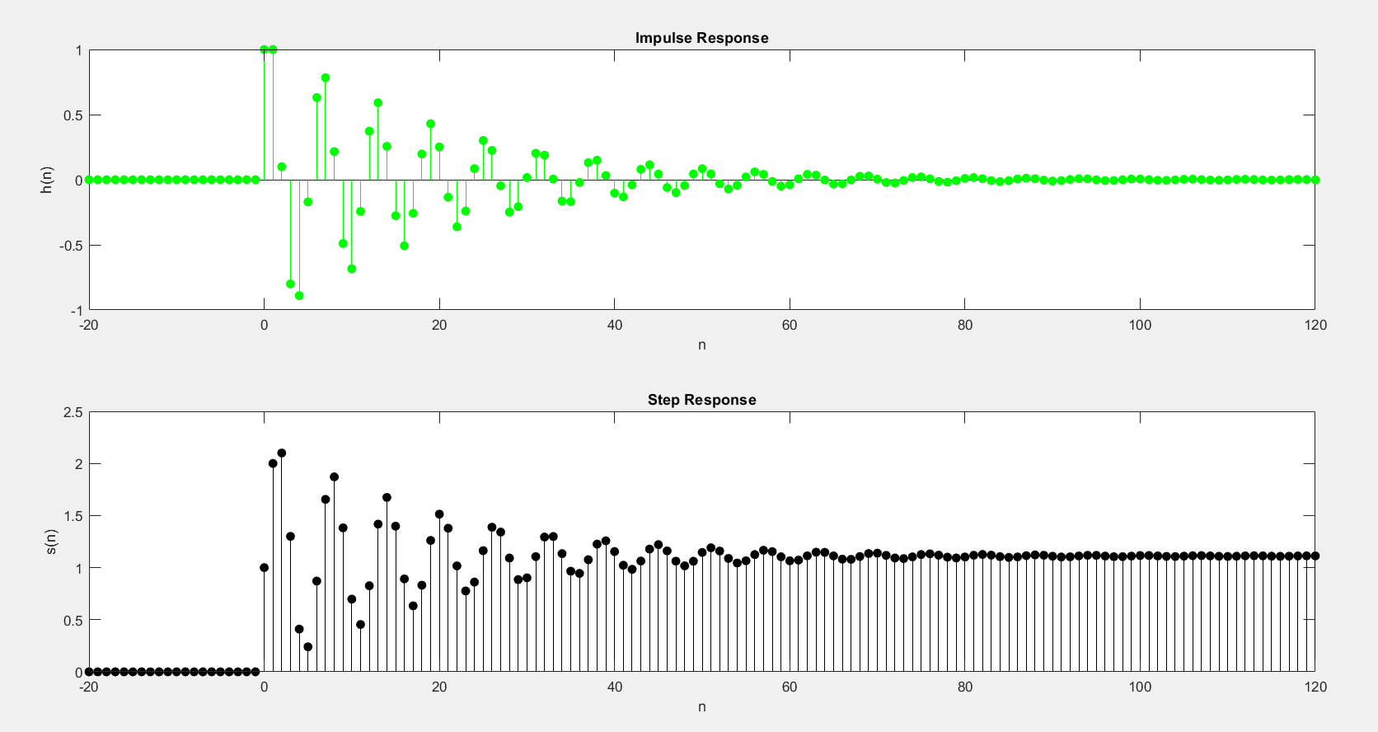
2. Generate a sinusoidal signal and add some random noise in it. Use the following difference equation to find out the filtered signal.
i. y(n)+y(n-1)+y(n-2)=x(n)
ii. y(n)+3/4y(n-1)+(1/8)y(n-2)=x(n)
iii. y(n)+1/4y(n-1)+(1/2)y(n-2)=x(n)+(1/2)x(n-1)
clear all
close all
clc

% Sampling frequency and time vector
fs = 1000;
t = 0:1/fs:1-1/fs;

% Create the original sinusoidal signal
x = sin(2*pi*2*t);
subplot(311);
plot(t, x);
title('Sinusoidal Signal');

% Add random noise to the signal
noise = rand(1, length(x)); % Generate random noise
signal = noise + x; % Add noise to the sinusoid
subplot(312);
plot(t, signal);
title('Sinusoid After Adding Noise');

% Apply the first filter (y(n) + y(n-1) + y(n-2) = x(n))
num1 = [1]; % Numerator coefficients (x[n] terms)
denum1 = [1, 1, 1]; % Denominator coefficients (y[n] terms)
f1 = filter(num1, denum1, signal); % Apply filter
subplot(411);
plot(t, f1);
title('Filtered Signal (y(n) + y(n-1) + y(n-2) = x(n))');

% Apply the second filter (y(n) + 3/4y(n-1) + 1/8y(n-2) = x(n))
num2 = [1];
denum2 = [1, 3/4, 1/8];
f2 = filter(num2, denum2, signal); % Apply filter
subplot(412);
plot(t, f2);
title('Filtered Signal (y(n) + 3/4y(n-1) + 1/8y(n-2) = x(n))');

% Apply the third filter (y(n) + 1/4y(n-1) + 1/2y(n-2) = x(n) + 1/2x(n-1))
num3 = [1, 1/2]; % Numerator coefficients (x[n] + 1/2x[n-1])
denum3 = [1, 1/4, 1/2]; % Denominator coefficients (y[n] + 1/4y[n-1] + 1/2y[n-2])
f3 = filter(num3, denum3, signal); % Apply filter
subplot(413);
plot(t, f3);
title('Filtered Signal (y(n) + 1/4y(n-1) + 1/2y(n-2) = x(n) + 1/2x(n-1))');
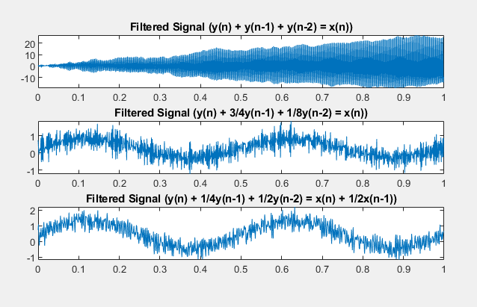
3. Find the impulse response of the following systems.
i. Moving Average System (MA)
ii. Auto-Regressive System (AR)
iii. Auto-Regressive Moving Average System (ARMA)
(Google these systems and simulate them by using their difference equations)
CODE
clear all;
close all;
clc;

% Define the impulse sequence
[x, n] = impulsesequence(0, -50, 150); % Impulse sequence from n=-50 to n=150

% 1. Impulse Response of Auto-Regressive System
num1 = [1]; % Numerator coefficients (for x[n])
denum1 = [1, 0.3]; % Denominator coefficients (for y[n] terms)
h1 = filter(num1, denum1, x); % Compute impulse response
subplot(311);
plot(n, h1);
title('Impulse Response of Auto-Regressive System');
xlabel('n');
ylabel('h1[n]');

% 2. Impulse Response of Moving Average System
num2 = [1, 0.3, 5]; % Numerator coefficients (for x[n], x[n-1], x[n-2])
denum2 = [1]; % Denominator coefficients (for y[n])
h2 = filter(num2, denum2, x); % Compute impulse response
subplot(312);
plot(n, h2);
title('Impulse Response of Moving Average System');
xlabel('n');
ylabel('h2[n]');

% 3. Impulse Response of ARMA System
num3 = [1, 9]; % Numerator coefficients (for x[n], x[n-1])
denum3 = [1, 1/6, 0, 1]; % Denominator coefficients (for y[n], y[n-1], y[n-3])
h3 = filter(num3, denum3, x); % Compute impulse response
subplot(313);
plot(n, h3);
title('Impulse Response of ARMA System');
xlabel('n');
ylabel('h3[n]');

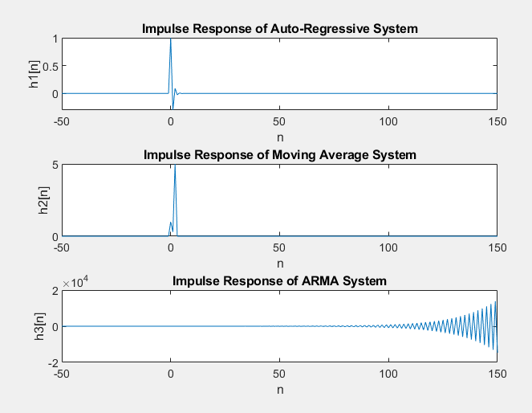

QUESTIONS

1. Define convolution?
Convolution is an operation (shifting, multiplication, and summation, for continuous and discrete time, respectively) that relates the output of a linear and time-invariant (LTI) system to its input and its impulse response. It returns output signal based on knowledge about the system’s unit impulse response. It provides the mathematical framework for digital signal processing.
2. Do the operands of the convolution in experiment 1 of Section B need to be the same length?
For the convolution of two signals i.e. the input and impulse response of the system, need not to be same. Convolution can be applied to operands having different lengths and the length of convolved signal (the output) will also be different from both the signals convolved even when having same lengths.
3. How long is the result y, if the operands (h and x) are 6 and 5 samples long?
Length of y in given case will be 10, which can be calculated as under,
Length of y = length of x + length of h – 1.
= 6 + 5 -1 = 10
4. What is the general rule for calculating the length of y from the lengths of h and x?
For finding the length of convolved signal we use the following formula,
Length of y = length of x + length of h – 1.
5. Does convolution obey commutative property?
Convolution obeys commutative property in both continuous and discrete domains. Which implies that the system with input signal x(t) and impulse response h(t) and the other with input signal h(t) and impulse response x(t) both give the same output y(t).
x(t) * h(t) = h(t) * x(t) = y(t)
or
x[n] * h[n] = h[n] * x[n] = y[n]

6. What is the significance of MA, AR & ARMA System?
Moving averages are widely used in technical analysis, a branch of investing that seeks to understand and profit from the price movement patterns of securities and indices. Generally, technical analysts will use moving averages to detect whether a change in momentum is occurring for a security, such as if there is a sudden downward move in a security’s price. The legacy of the financial crisis lives on in today’s autoregressive models like For example, an autoregressive model might seek to predict a stock's future prices based on its past performance.
Autoregressive moving average (ARMA) models play a key role in the modeling of time series. The linear structure of ARMA processes also lead to a substantial simplification of linear prediction.

